Programming Exercise 3-7

Jalill Hayes

Hierarchy chart:

Main

getFatgrams()

showResults()

setCarbCals()

setFatCals()

getCarbGms()

Pseudocode:

// Global constants for conversion factors

Constant Real CALSFROMFAT = 9

Constant Real CALSFROMCARBS = 4

// Main module

Module main()

// Local Variables

Declare Real gmsFat, gmsCarb, calsFat, calsCarb

// Get fat grams

Call getFatGms(gmsFat)

Call getCarbGms(gmsCarb)

// Calculate calories from fat

Call setFatCals(gmsFat, calsFat)

// Calculate calories from carbs

Call setCarbCals(gmsCarb, calsCarb)

// Display the results

End module

// The getFatGms() module reads weight of fat consumed and stores it in inputFat

Module getFatGms(Real Ref inputFat)

Print “enter fat grams consumed: “

Read inputFat

End module

// The getCarbGms() module reads the weight of carbs consumed and stores it in inputCarbs

Module getCarbGms(Real Ref inputCarbs)

Print “Enter carbohydrate grams consumed: “

Read inputCarbs

End module

// The setFatCals() module sets the fat calories and stores it in calsFat reference variable

Module setFatCals(Real gmsFat, Ref calsFat)

Set calsFat = gmsFat * CALSFROMFAT

End module

// The setCarbCals() module sets the carbohydrate calories and stores it in calsCarb reference variable

Module setCarbCals(Real gmsCarb, Ref calsCarb)

Set calsCarb = gmsCarb * CALSFROMCARB

End module

// The showResults() module accepts the calculated variables and displays them

Module showResults(gmsFat, gmsCarb, calsFat, calsCarb)

Print(“Grams of fat: “, gmsFat

Print(“Resulting calories: “, calsFat)

Print(“Grams of carbohydrate: “, gmsCarb)

Print(“Resulting calories: “, calsCarb)

End module

Flowchart:

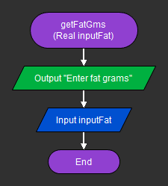

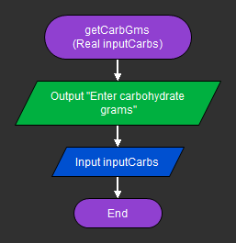

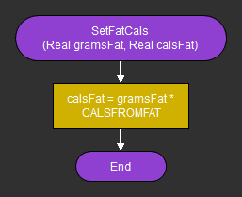

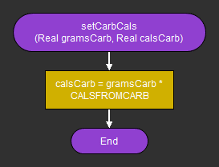

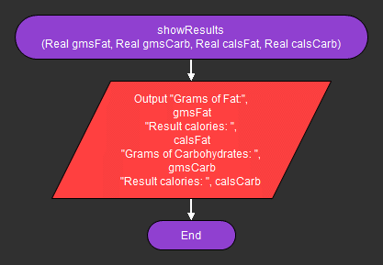

**Flowchart:**

